Code commit:

Create an IAM user and generate Access key and Secret key. We can use existing User also but we need to add code commit permission:

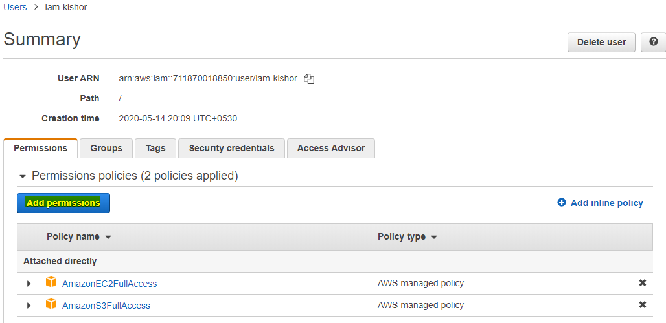

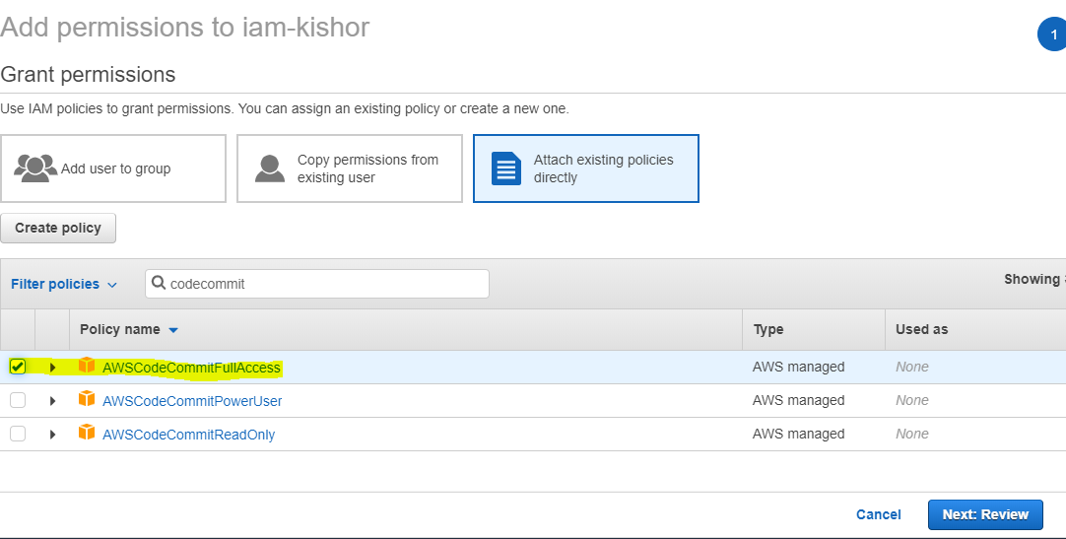

Install git on your machine.

Set up HTTPS git credentials for code commit.

Sign in with IAM user credentials

Go to IAM user and generate git credentials:

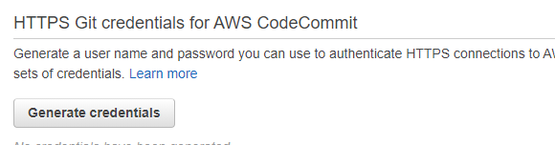

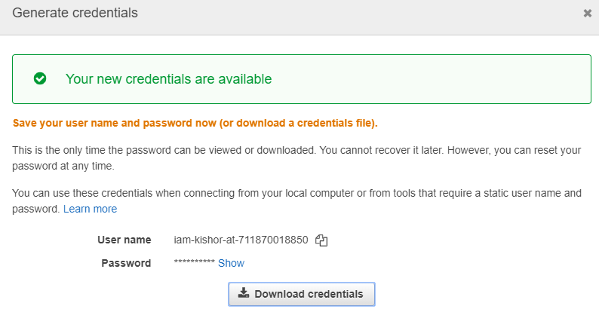

Next go to CodeCommit in AWS console and create a repository:

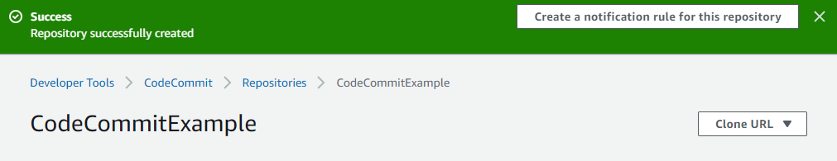

Add a source code file to this repo.

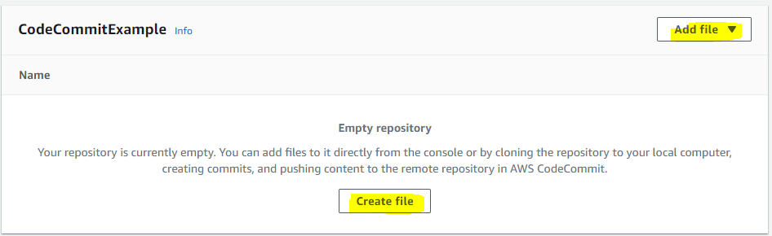

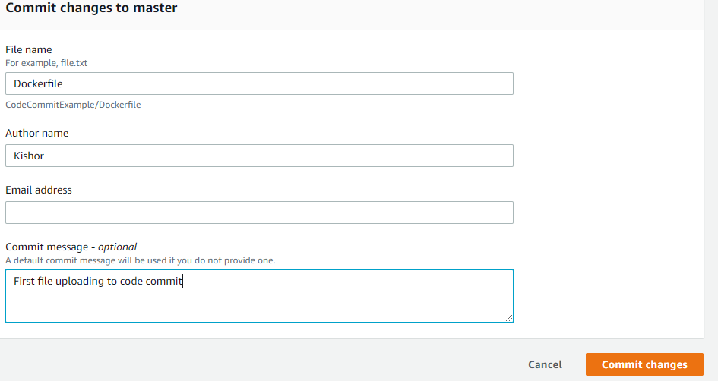

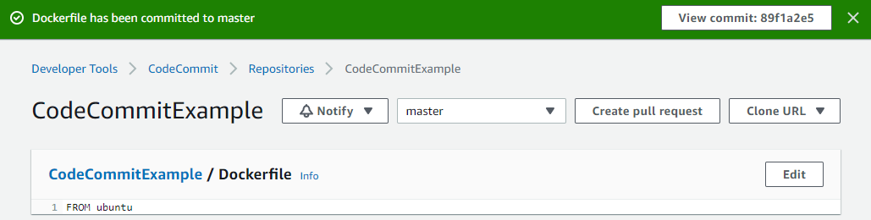

Create a pull request:

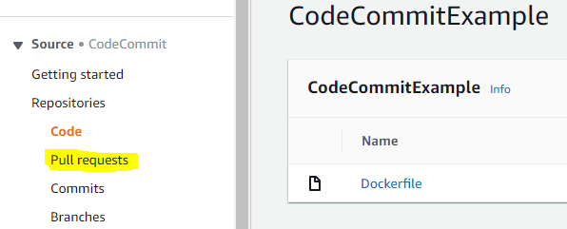

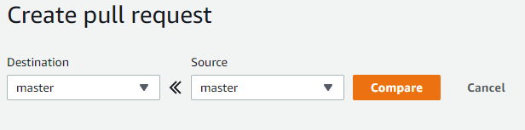

Branching:

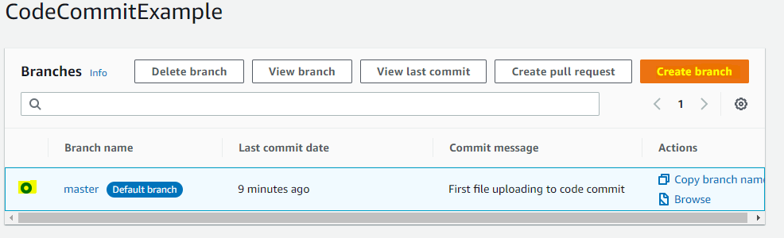

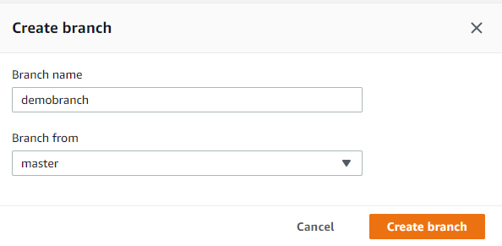

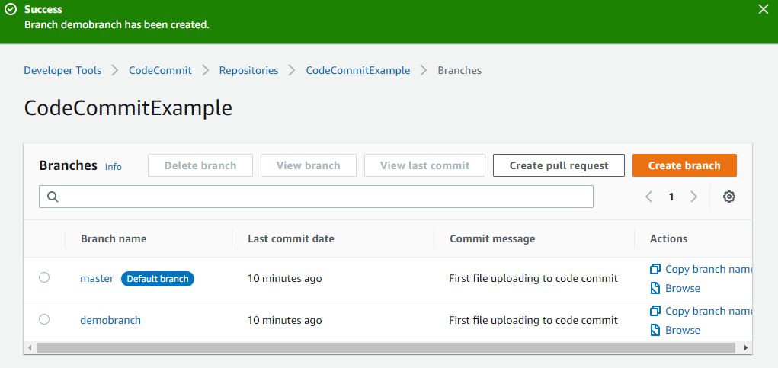

Go to the newly created branch and add a file:

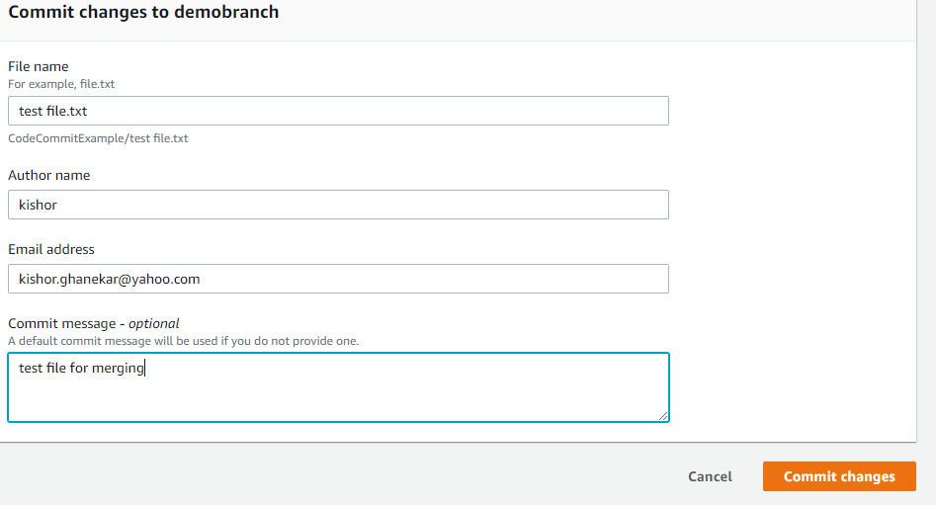

Click on Create Pull Request

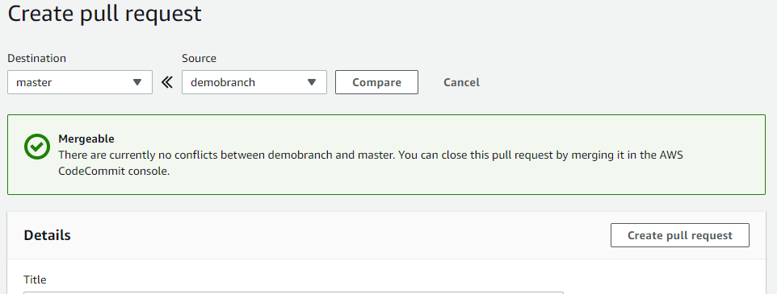

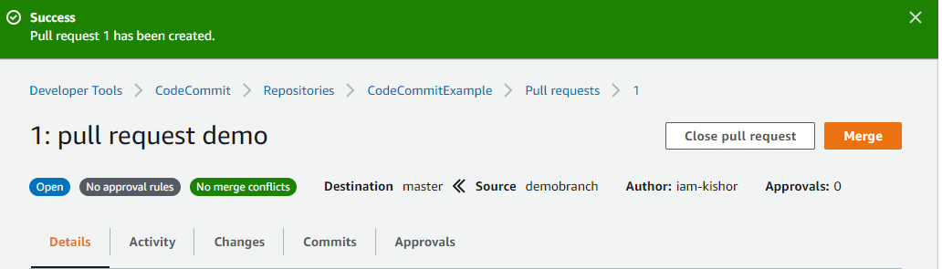

Click on Merge for merging

